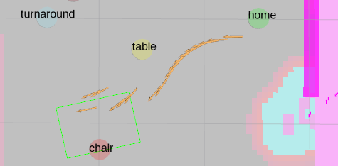9/17/25 9:30AM

9/17/25 10:40am

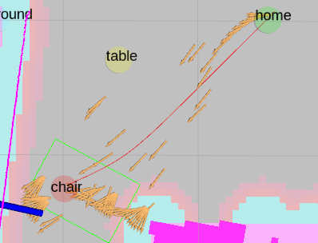FAIL - after 1st try at fixing shift

9/17/25 11:05am

rviz=odom  
hallway to home - notice no shifts in odom frame, only in rviz=map frame

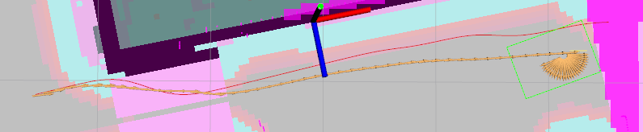

9/17/25 11:15 home to microwave - glitched during narrows

notice it followed yellow path not red

